4th Grade Syllabus
Mrs. Christensen’s Class

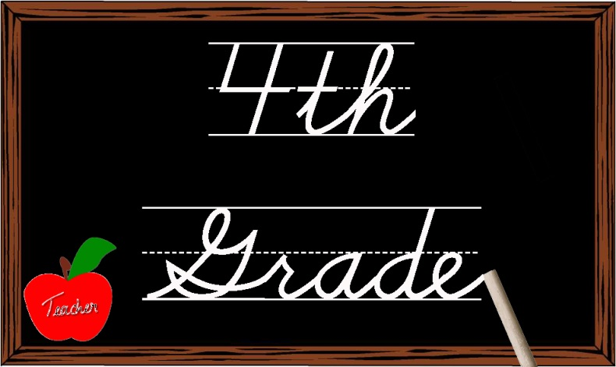

COMMUNICATION
When and how often you can expect to hear from me:
Please check our class website for weekly news and updates. I will contact you through email or phone for specific matters regarding your child.

Website: www.MrsChristensensClass.yolasite.com

4th GRADE TEACHER | CLASS | ROOM | SUBJECT TAUGHT | EMAIL
Mrs. Lowry | 4A | #201 | Social Studies | a.lowry@stephen.org
Mrs. Christensen | 4B | #203 | Math | a.christensen@stephen.org
Mrs. Figura | 4C | #202 | Science | t.figura@stephen.org

Subjects and Content to be covered
SUBJECT | Math | Religion | Science | Social Studies
TEXT BOOK | Houghton Mifflin (2007) | Call to Faith (2012) | Interactive Science – Pearson (2012) | Harcourt Horizons (2010)
CONTENT TO BE TAUGHT | - Addition and subtraction of large numbers  - Multiplication and division of large numbers  - Place value to millions  - Fractions  - Decimals  - Geometry  - Time and money  - Probability and Statistics | - Beatitudes  - Ten Commandments  - Rosary  - Saints  - Sacraments  - Vocations  - Liturgical Year  - Stewardship  - 3rd-5th Grade Masses on Wednesdays  - All School Masses on Fridays  - Weekly visits from Father Mark | - Earth’s land and matter  - Nutrition (Archdiocesan assessment)  - Living things  - Electricity  - Weather | - States  - Regions of the U.S.  - Nebraska history  - Scholastic News

SUBJECT | Reading | English/Writing | Spelling | Vocabulary Workshop
TEXT BOOK | Text used: McGraw-Hill ( 2008) | Sadlier Grammar Workshop (2007) | N/A | Sadlier Vocabulary (2005)
WHAT TO EXPECT CONTENT | - Comprehension  - Cause/Effect  - Setting/Characters  - Inferences  - Drawing Conclusions  - Synonyms/Antonyms  - Fact/Opinion  (read 20 minutes at home each night) | - Sentence structure  - Nouns  - Verbs  - Pronouns  - Adverbs  - Adjectives  - Combining sentences  - 6 Traits of Writing | - Continuing Phonics/Spelling program from 3rd grade  - 13 words with a common phonetic spelling pattern (plus the 12 vocab. words for a total of 25 Spelling words)  - List sent home on Monday of the first week  - Spelling contract given for each list (due Friday)  - Test at the end of the first week  Angela Christensen | - 12 words  - List sent home on Monday of the first week  - 2 weeks for each unit  - Study nightly (2 or 3 words each night)  - Need to know ALL definitions & most synonyms/antonyms  - Vocabulary Workshop on-line practice

HOMEWORK

Homework Expectations:
- Assignments average 40 minutes to complete each night, not including studying for tests and working on special projects.
- Nightly review of spelling words, vocabulary lists, and math facts is strongly encouraged.
Parent Involvement
- Assistance with homework may be needed with difficult concepts at times. We do ask that you do not help them to where they cannot pass tests on their own. Fourth grade is gearing the students up for more independence. Please help us help your children!

Missing Assignments
- If homework is not completed on time, students may receive a demerit or stay after school until 3:45 to complete the assignment. Both of these options result in 5 points taken off the grade and count towards missing the earned free dress day. Students must have less than 3 missing assignments or demerits to qualify for earned free dress.
Missing Work: Illness or vacation
- We are aware that at times students will miss school due to illness or vacation. When your child is absent it is his/ her responsibility to see each teacher to get their assignments and have them turned in no more than two days after their return to school.
- It is appreciated if we can be told of vacations at least a couple days in advance. We will do our best to get work ready before the trip, but sometimes work will have to be completed upon return.

Behavior Policy
- Students receive a new demerit card once a month. If a student chooses to break a rule during the day, he/she will receive one demerit or more depending on the severity of the action. The form that the student will fill out and sign will go home that night and needs to be signed by a parent and returned the next school day.
- After receiving 3 demerits or missing 3 assignments, earned free dress day will be lost. Five demerits received during a month will result in a meeting with the guidance counselor during the first semester and Dr. Williby the second semester.
- We will use the Boys Town model for Well-Managed Schools. We are focusing on corrective teaching and effective praise this year.

Boys Town Skills:
Some of the skills we will be working on this year include:
- Greeting others
- Getting the teacher’s attention
- Accepting “No” for an answer
- Following instructions
- Accepting criticism
- Disagreeing appropriately
- Making an apology
- Accepting compliments
- Asking for help
- Asking permission

School Wide Rules
- We will be responsible for our actions.
- We will include everyone in our group activities.
- We will help others if they are being bullied.

GRADING
- Students will be assessed in various formats throughout the year including daily work, projects, written tests, and informal observations.
Grade Scale
98-100 A+  95-97 A  93-94 A- | 91-92 B+  88-90 B  86-87 B- | 84-85 C+  80-83 C  78-79 C- | 76-77 D+  72-75 D  70-71 D-

Extra Credits and Retakes
- At various times throughout the year your child will be offered a chance to bring up lower grades. Extra credit is not mandatory. Extra credit will not be given at the end of a quarter or grading period to bring up low grades.
- Daily grades below 78% may require a student to make corrections at school or home (at the teacher’s discretion).
- Test grades below 78% may require a student to make corrections or retake the test (at the teacher’s discretion).

TYPES OF ASSESSMENTS AND FREQUENCY
- Students will be assessed on Spelling and Reading on a weekly basis. Math, Science, Social Studies, and Religion will be assessed at the end of every unit.
- Rocket Math (math facts will be done two to three times a week).
- All Omaha Catholic School students are given an Archdiocesan Assessment each year. The results of these assessments will be recorded and reported to the Archdiocese. These scores are used to gauge student achievement, develop new teaching and learning strategies, and to examine curriculum. This year, Fourth Graders will complete a Social Studies and Science assessment.

EDLINE & GRADED PAPERS
I will be updating grades on Edline every two weeks. Please be sure to check Edline and check over all graded papers on a regular basis in order to stay current on your child’s academic progress. Most graded papers will be sent home in your child’s Friday folder.

SPECIAL PROJECTS
- Book projects – about once a month
- Rosary project - October
- Saint project - November
- Pre-School buddies – September, November, April, May

Field Trips
- Mormon Trail Center in November or December. This in conjunction with Masterpiece Art gingerbread house project
- Lincoln Field Trip in May. We will be visiting the Capitol, Nebraska History Museum, and Morrill Hall.

